Report (Lab 4.2.1 to 4.2.4)

Lab 4.2.1

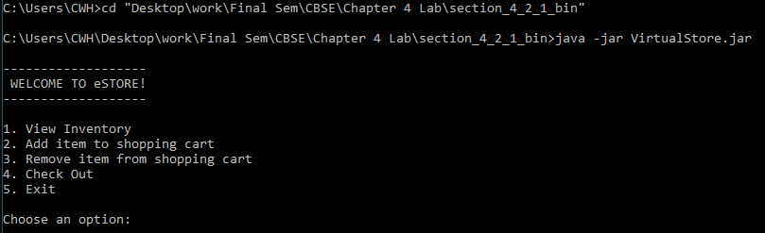

To view the inventory enter 1

Add item to shopping cart

Remove some items from the cart

Check out & exit

We can see the dependency of this program that the Inventory class depends on the Product class and the Store class depend on both classes that we mention before. Which makes it dependency depth 2.

Lab 4.2.2

Above shows, the result of running the 4.2.2 program by choosing the no of the item that is not being listed.

So, there will still allow users to check out with an empty cart.

There will be a problem if enter and remove the item from the shopping cart, it will terminate the program since there is nothing to choose to remove.

From here we can see it implementing a base library that would be shared by all the components. Just like the Inventory class implementing the InventorySerivce. So, we can reduce the dependency depth by applying the 5 rules of componentizing.

Lab 4.2.4

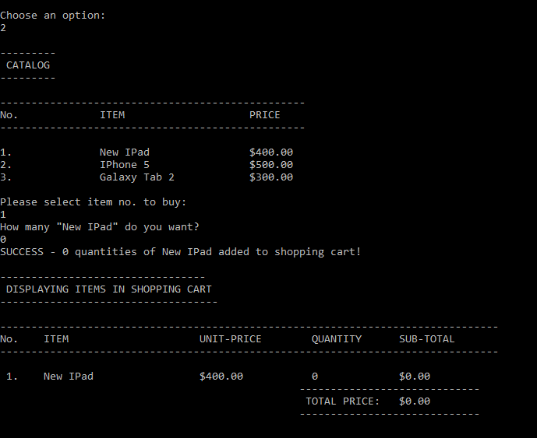

The above shows the result of trying to add zero items to the cart

From the figure above we are trying to remove the zero items in the cart with 3 items after selecting the respective item. Seems like zero also will have the same Error.

Here we can see in order to accommodate the promotional 10% discount, a new Promotional Shopping Cart Component is created. Which provides the same ShoppingCartService interface, but the implementation of the getPrice() method is modified to provide a 10% discount at 62nd lines of code totalPrice multiplied by 0.9.